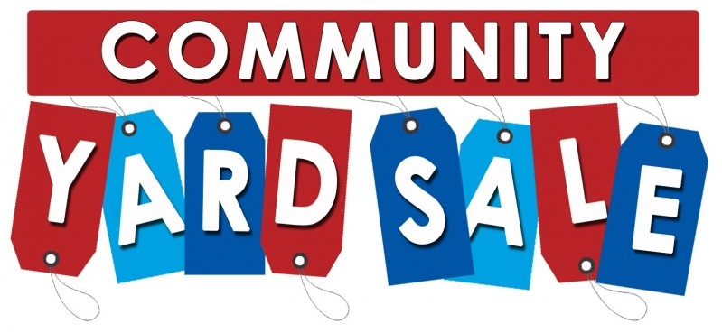On Saturday, June 9, Donation United Methodist Church will host a Community Yard Sale in the church parking lot. Sale will start at 8 am.
There are a couple ways to participate.
- You can rent your own space for $10.00 a table
- You can rent your own space for $20.00 a table, and whatever you don’t sell, the church will dispose of for you
- You can donate your items to the church table (all items must be delivered to the church no later than Thursday June 7th.) Contact Erin McCool for more information.
If you are donating to the church table or want the church to dispose of your items after the sale, some restrictions apply (such as no appliances or large furniture items, see member for details). All items must be in good working order or gently used.
To reserve your space fill out the form below and return it to:
- Donation United Methodist Church, 7333 Loop Road, Huntingdon, PA 16652
- Contact Erin McCool at erinmccool@comcast.net or (814)386-1802
Donation United Methodist Church YARD SALE Registration
Name:
Address:
Telephone/Contact Information:
# of Tables Requested:
The yard sale will be located in the church parking lot. You may arrive as early as 6:30 am to set up your space. All spaces must be ready to sell by 8:00 am.
I understand I am responsible to clear my space of all merchandise at the end of the day.
I am requesting the church dispose of items I do not sell. I understand any item left may be sold by the church and there is an additional $10.00 fee.
Signature:

